Hands-on 3: Professional Error Handling

1. Prerequisites
- Terminal Access: Open your VS Code terminal.
- Basic Knowledge: Understanding of functions and multiple return values (from Hands-on 2).

2. Why are we doing this?
In many languages, an error "throws" an exception that crashes the program unless caught. In Go, we treat errors as first-class citizens. This prevents "hidden" crashes and ensures that you, the developer, decide exactly how to handle every "what-if" scenario—whether it's a missing file, a bad input, or a lost database connection.

3. Objective
- Learn to use the error interface.
- Create custom errors using errors.New() and fmt.Errorf().
- Implement the "Check and Return" pattern.
- Understand when to use panic (hint: almost never) and recover.
- Mini-Project: Upgrade your Calculator or Employee Manager with production-grade error validation.

4. Steps To Follow

Step 1: The Basic Error Pattern
Create basic_error.go. We will see how Go functions return a value and an error side-by-side.
package main
import (
"errors"
"fmt"
)
// Function returns a string and an error
func checkUsername(name string) (string, error) {
if len(name) < 3 {
// Creating a simple error
return "", errors.New("username is too short")
}
return "Welcome " + name, nil // nil means 'no error'
}
func main() {
result, err := checkUsername("Ab")
if err != nil {
fmt.Println("ERROR CAUGHT:", err)
return
}
fmt.Println(result)
}

Run command:
go run basic_error.go

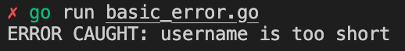

Step 2: Dynamic Errors with fmt.Errorf
Create dynamic_error.go. Sometimes you need your error message to include the data that caused the error.
package main
import "fmt"
func validateAge(age int) error {
if age < 0 || age > 120 {
// fmt.Errorf allows us to inject variables into the error string
return fmt.Errorf("invalid age %d: must be between 0 and 120", age)
}
return nil
}
func main() {
err := validateAge(150)
if err != nil {
fmt.Printf("Validation Failed: %v\n", err)
}
}

Run command:
go run dynamic_error.go

Step 3: Panic and Recover (The Safety Net)
Create panic_recover.go. panic stops the program immediately. recover can stop the "dying" process, but it should only be used for critical failures.
package main
import "fmt"
func handlePanic() {
if r := recover(); r != nil {
fmt.Println("RECOVERED from a critical error:", r)
}
}
func dangerousOperation() {
defer handlePanic() // Always use defer with recover
fmt.Println("Starting operation...")
panic("System overheat!") // Triggering a crash
fmt.Println("This line will never run.")
}
func main() {
dangerousOperation()
fmt.Println("Program continues safely.")
}

Run command:
go run panic_recover.go

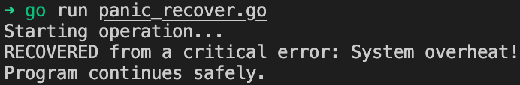

5. Mini-Project: Robust User Registration System
Create registration.go. This project combines everything. It validates user data and uses nested error handling to provide specific feedback.
package main
import (
"errors"
"fmt"
"strings"
)
// Custom error variables for specific comparison
var (
ErrEmptyName = errors.New("name cannot be empty")
ErrShortPass = errors.New("password must be at least 6 characters")
)
func registerUser(name, password string) error {
if name == "" {
return ErrEmptyName
}
if len(password) < 6 {
// Wrapping an error with context
return fmt.Errorf("registration failed for %s: %w", name, ErrShortPass)
}
fmt.Printf("User %s successfully registered!\n", name)
return nil
}
func main() {
users := []struct {
name string
pass string
}{
{"Gopher", "123"}, // Should fail (too short)
{"", "secretpass"}, // Should fail (empty name)
{"Alice", "longpassword"}, // Should pass
}
for _, u := range users {
fmt.Printf("Processing %s...\n", u.name)
err := registerUser(u.name, u.pass)
if err != nil {
// Check if the error is specifically ErrEmptyName
if errors.Is(err, ErrEmptyName) {
fmt.Println("Critial Failure: We need a name to proceed.")
} else {
fmt.Printf("Warning: %v\n", err)
}
}
fmt.Println("--------------------")
}
}

Run command:
go run registration.go

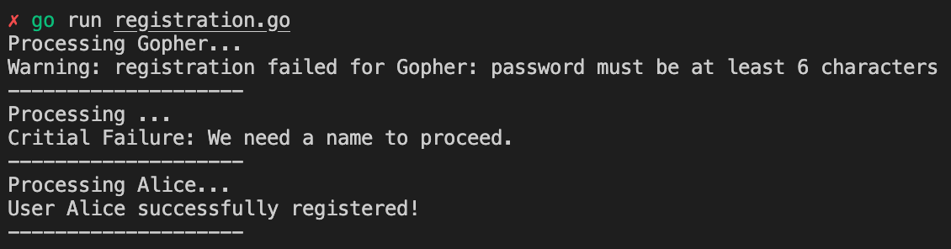

6. Checklist of Accomplishments
- [ ] Error Creation: Used errors.New for static messages.
- [ ] Formatted Errors: Used fmt.Errorf for dynamic context.
- [ ] Nil Checking: Implemented the if err != nil pattern.
- [ ] Panic/Recover: Understood how to stop and restart a failing execution flow.
- [ ] Error Comparison: Used errors.Is to check for specific error types.

7. Conclusion
In this hands-on, you've moved from "happy path" coding to "defensive" coding. You now understand that in Go, an error is just information. By returning errors instead of throwing exceptions, you make your code easier to debug and much more reliable for production environments.

Congrats!
You are now writing Go code that is crash-resistant! You’ve mastered the most important pattern in the entire language.

